############# KVM ###################
vi /etc/multipath.conf
1059 systemctl restart multipathd.s
1060 systemctl restart multipathd.service
1061 multipath -ll | grep -i DRNEO-MZP-WBAP01
1062 pvs
1063 pvcreate /dev/mapper/DRNEO-MZP-WBAP01-DISK1
1064 vgs
1065 vgcreate DRNEO-MZP-WBAP01-DVG1 /dev/mapper/DRNEO-MZP-WBAP01-DISK1
1066 lvs
1067 lvcreate -L 100%free -n DRNEO-MZP-WBAP01-DLV1 DRNEO-MZP-WBAP01-DVG1
1068 lvcreate -L 100%FREE -n DRNEO-MZP-WBAP01-DLV1 DRNEO-MZP-WBAP01-DVG1
1069 lvcreate -l 100%FREE -n DRNEO-MZP-WBAP01-DLV1 DRNEO-MZP-WBAP01-DVG1
1070 ip r

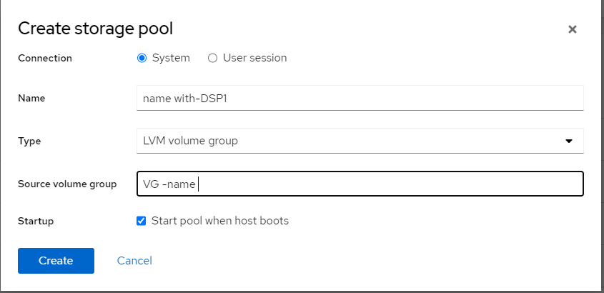

Need go to virtual machine select the VM

Click on add disk

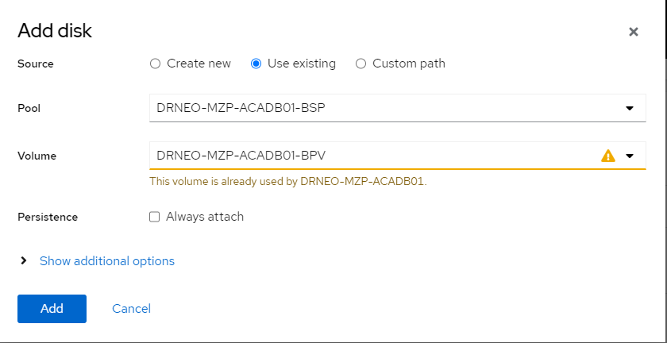

Go inside vm
24 hostname
25 lsblk
27 pvs
28 pvcreate /dev/vdb
29 vgcreate DATAVG /dev/vdb
30 lvcreate -l 100%free -n DATALV DATAVG
31 mkdir /data
32 mkfs.xfs /dev/DATAVG/DATALV
33 vi /etc/fstab
34 mount -a
35 systemctl daemon-reload
36 mount -a
37 df -hT

